**HTML & Website Design**

**Project Group Process Workbook**

**2015**



## Template 1 Roles & Responsibilities

**Roles & Responsabilities**



In order for the group to work effectively it is necessary for members to take responsibility for specific tasks. Assign a group member to each of the roles. If a group member is not performing their role this must be managed within the group. If this cannot be addressed within the group please contact one of your Project lecturers as soon as possible.

|  |  |  |
| --- | --- | --- |
| Role | Responsibility | Team Member |
| Project manager | Ensures each member remains on task and ensures that meeting times are used appropriately | Keith Feeney |
| Developer 1 | Ensures that all tasks are designed and completed on schedule | **Cedric Vecchionacce** |
| Developer 2 | Ensures that all tasks are designed and completed on schedule | Dermot Forde |

## Template 2 Understanding the Problem



**INTERPRET THE PROBLEM**

Using the headings below, discuss the details of the assignment amongst group members and fill out the template.

|  |
| --- |
| 1. Define the problem. What are you being asked to do? Do you fully understand what has to be delivered when complete?   **We have been asked to complete a website design for a garage specialising in Mercedes in Eamon Nolan Motors. When complete, the website will have s selection of Mercedes cars for sale in a Showroom area.**  **It will specialise in Mercedes cars and car parts but any model can be brought to the garage. It will show what the company is about with a selection of parts, etc. that are available. It will look appealing and welcoming and will be easy to navigate.**  **The outcome will br analysed and written in a project report. We will be using XHTML and Javascript.** |
| 1. List the different XHTML concepts & Web design considerations that you believe will need to be understood in order to complete this assignment.   **We will be using correct typing and extra care in HTML tags and correct use of elements and attributes. consisting of, for example, these tags;**   * **Img** * **Br** * **Tables – td / tr** * **Ul / ol – li** * **Headings (h1, h2…)** * **And many more** |
| 1. What approach will be taken to implement the website e.g. CSS/tables? Explain your reasons for decisions taken.   **We will be using CSS for the different aesthetics of the site. We are using this as it’s much simpler to edit fonts, colours, etc. in bulk. Using inline styling is considered obsolete, so CSS would be more beneficial.**  **We will be using tables for e.g. showing different images in the Showroom page. We will be able to control these better than just using the <img> on its own.**  **We will be using forms on the contact page, etc.** |
| 1. What has been your Group’s strategy for validating your code? How have you approached this?   **We will be using both strict and traditional format to validate the code in XHTML. This will be done and w3c.org.** |

## Understanding the Problem



**Project requirements**

List the requirements that you have for your website

|  |
| --- |
| 1. What is the overall goal of your website?   **The overall goal of the website is to show a pleasant looking site that’s easy to navigate and looks professional.**  **The overall concept of the website is to show off new and used cars, with optional financing. They have signed a new contract with Mercedes to be the main Mercedes dealer in Leinster.** |
| 1. What are the functional requirements for your site? What will the site **do**?   **The site should showcase exclusive deals that can be expected for all customers. It will also have a nice Showroom for all the brands and models.**   * **Navigation links** * **There will be a drop down menu on the left side.** * **There will be an interactive map.** * **There will be appointment booking for the likes of test driving new cars.** * **A contact form** |
| 1. What are the non-functional requirements of your site? Do you have a preference for the look and feel of the site?   **Good navigation**  **Good feeling and good quality**  **Good quality images**  **The site will be simple looking but smart and professional with neutral tones.  It will be two toned and will visually look good on the eye.** |

|  |
| --- |
| 1. What other requirements do you want to achieve in your site?   **Colouring: Black-green and grey-white**  **Sidebar information**  **Footer contact details etc etc.**  **Not too cluttered / bombardment of information.**  **Easy to navigate**  **Research on the garage / service centre section of a car dealership/showroom website:**  **AORMotors.ie**   * General assessment:   + The Service Centre section has just a small bit of text and two photos in the main content section. This is not designed well and lacks information. * Improvements:   + Could have several different items on what car services they provide   + Pricing on different services or parts that could be replaced.   + Detailed information on different car parts and hat they do.   + The two photos align horizontally and the width is the full content section, the could be rearranged with text wrapping * Ideas for Nolan’s Car Showroom, Servicing section   + Detailed information on products and services   + Pricing on products and services   + Photos that complement the page and not take focus of important information.   **AtlasAutoService.ie**   * General assessment:   + The service section of the site contains a lot of information and lacks pictures.   + The colour design; yellow content section on blue background is a little difficult on my eyes. * Improvements:   + Colour relaxing, maybe make the default colours a light blue and light yellow.   + Less text, really wold only need a summary of what is done.   + I do like the fact it has a “Book online” link for each servicing.   + Photos to enhance the page * Ideas for Nolan’s Car Showroom, Servicing section   + Ensure that the text is limited, but not too limited   + Colours shouldn’t be too bold, should be easy on the eye   + Pictures should be used, to enhance the page.   **AdvancePitStop.com**   * General assessment:   + Extremely well laid out and easy to read with neutral colours   + It has links to book online and request a call-back with prices   + Each section is divided and can be easy read. * Improvements:   + The page is very text heavy   + Would be nice to see some photos in there (could make it look tacky)   + Sidebar on right with a section of small photos. * Ideas for Nolan’s Car Showroom, Servicing section   + Could implement several features from this site.   + Organisation seems to be key here.   **Research on the About section of a car dealership/showroom website:**  **1. FORD MOTORS.IE**  The ABOUT section is quite good with photos, it has company information and a mission statement.  It also has heritage, Annual Reports and History of Ford in Ireland.  **IMPROVEMENTS**  It could give opening times and closing times.  **IDEAS FOR PROJECT**  We could use the mission statement or a bit of history about the garage.  **2. MERCEDES ANNESLEY WILLIAMS**  The About section gives the opening and closing times which is quite important.  It also gives contact details of sales people for Mercedes like E-mail and phone numbers.  There is a navigation bar with links to Finance, Used Cars and After Sales.  **Improvements**  There is not much to improve on in this web site although there is no testimonials about people who have bought cars from Williams Motors.  **Ideas for Project**  We could use the opening and closing times, also the contact details like email and telephone numbers.  3. **PORSCHE IRELAND**  The About section is quite good, it gives the opening and closing times, contact information like email of sales people and phone numbers. You can also make a complaint. It also gives a photo of the staff and says a bit about their background.  **Improvements**  There is not much to improve on this website.  **Ideas for project**  I suppose we could use a photo of the staff and a bit about their background  Research on the Showroom section of a car dealership/showroom website:  Porsche.com:   * General assessment:   This one of the best references I found, nice layout, easy to navigate. Their show room is simplified as a pop up menu with all the models and specifications. (They have a whole page called porschemuseum.com in which you can actually see every single car). Each of the links in the pop up menu redirects you to interior, exterior and engine images. Focused on Porsche Life Style.   * Improvements:   Hard to find improvements for this page.   * Ideas for Project:  1. A drop down menu with 3 models per class (a, b or s). 2. Slide show for exterior, interior, engine. 3. Find Loads of images.   Audi.com:   * General Assessment:   They flipped things over. Their main page is a showroom for all models regarding price and summary of specs. Once you click on a model you get redirected to a dedicated page of that model where you find ALL info. Is easy to navigate. Focused on Innovation.   * Improvements: more usability in the navigation. * Ideas for project:  1. Images linked for interior, exterior and engine slideshows. 2. Video commercials for each model. 3. Prices need to be shown clearly 4. Add equipment and accessories link to shop menu.   Mercedes-benz.com:   * General assessment:   Very good website loads of info and history. Colours definitely match the Mercedes brand. Loads of News and Events, this will be the main reference for the page. No showroom page, more of a division between sport, classic, and events. They have diplomatic and corporate target sales as well.   * Improvements: Information could be gathered a little bit easier and some menus are very small, they could be a little bigger without interfering with the design * Ideas for project:  1. Link to all social media. 2. Language 3. Layout of slideshows important 4. Pop up windows for some features in the page. 5. About section for the showroom.   In general all pages have a great design and relatively good usability, all of them are lack of a page or a reference saying showroom but they have it implied in the navigation and the other pages they have, Mercedes and Porsche are very similar, and as really big companies they have too much information to put in just one page, they also give an interesting importance to the lifestyle of the brand, they target multiple audiences (young, mature, diplomatic and corporate. Audi focus on innovation and again life style aiming to a young audience and more sportive designs. |

## Template 3 Exploring Ideas

## Exploring ideas – What will the user interface look like?

Discuss possible designs for your website. Once the group decides on a design use Microsoft Word or a Balsamique Mockup to demonstrate the chosen design and layout of website.

AND

## Exploring Ideas

## Exploring ideas – What will the user interface look like?

**Include Wireframes here**

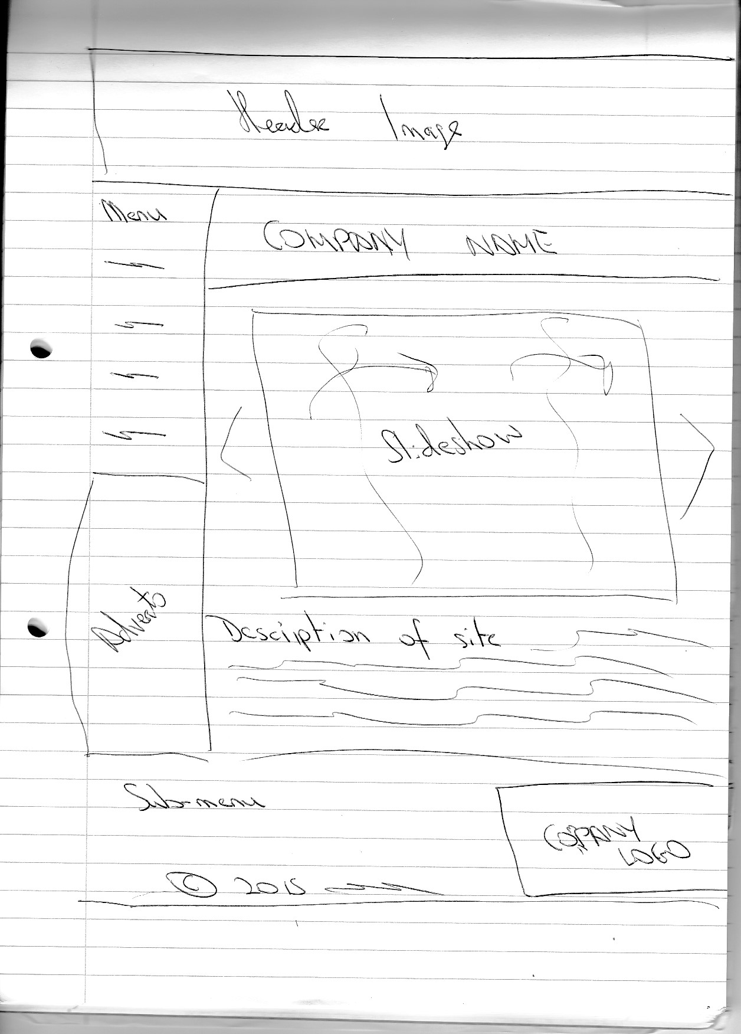

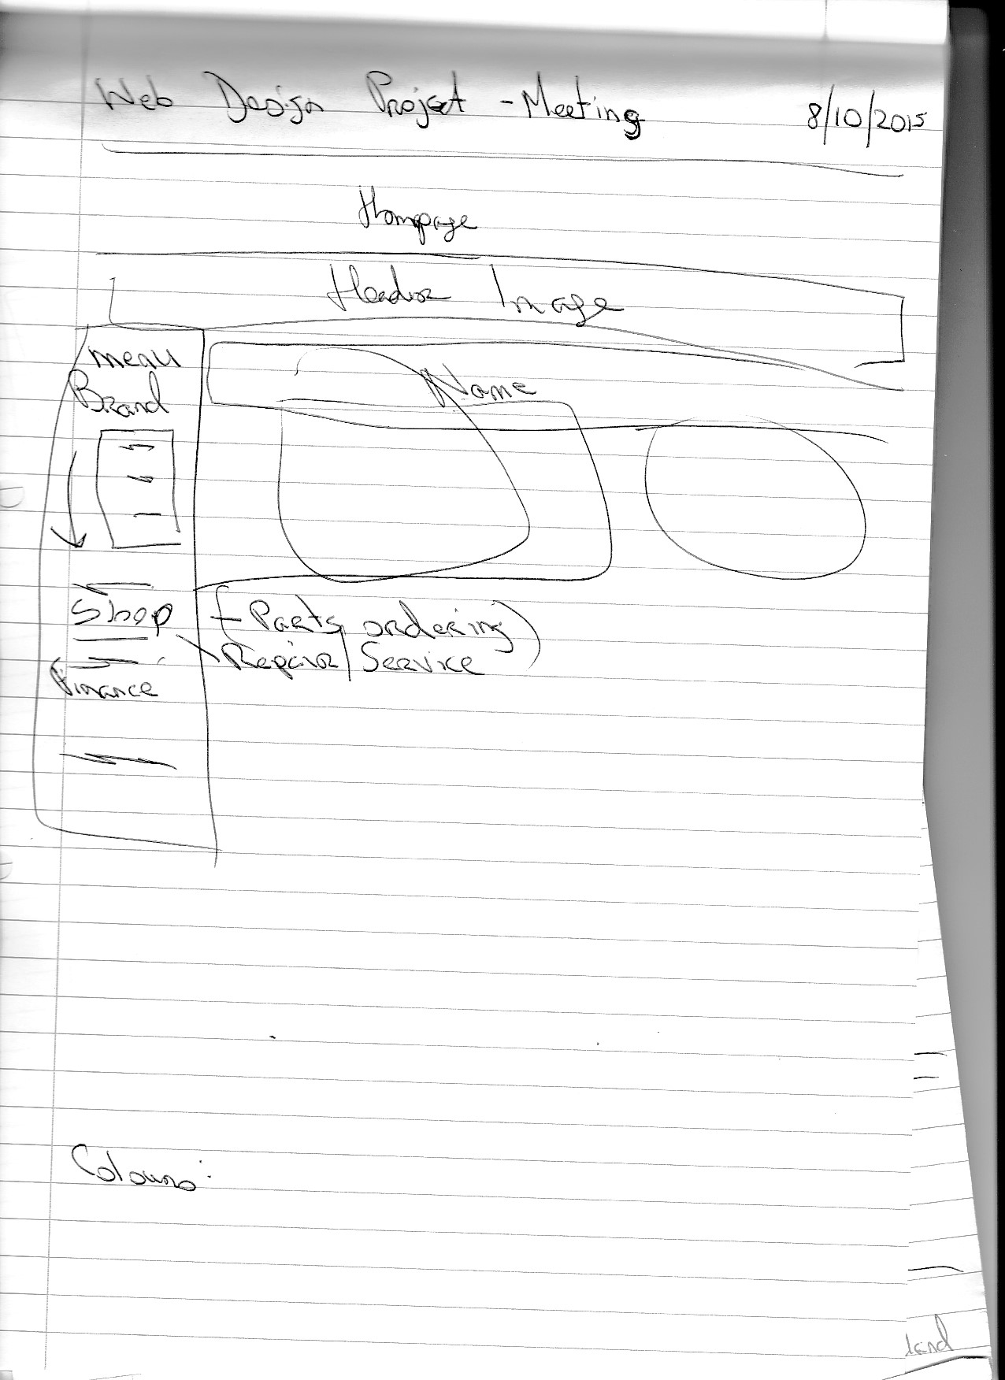

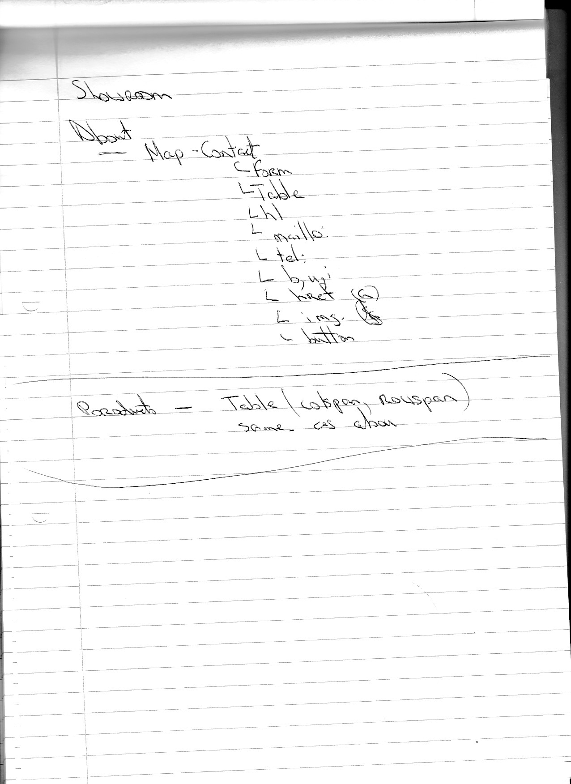

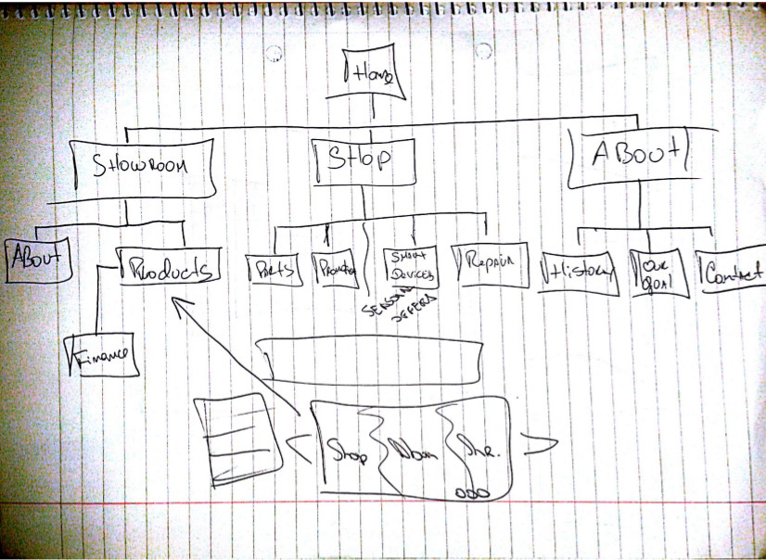

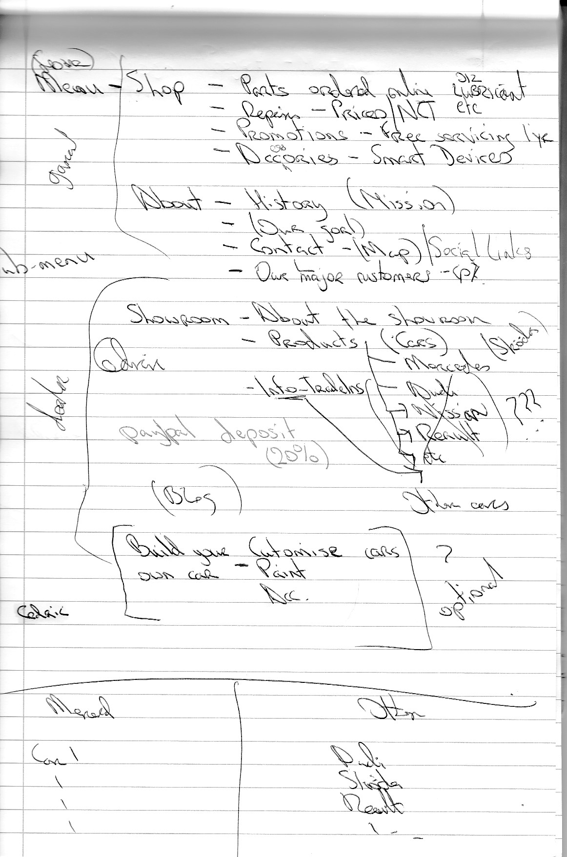

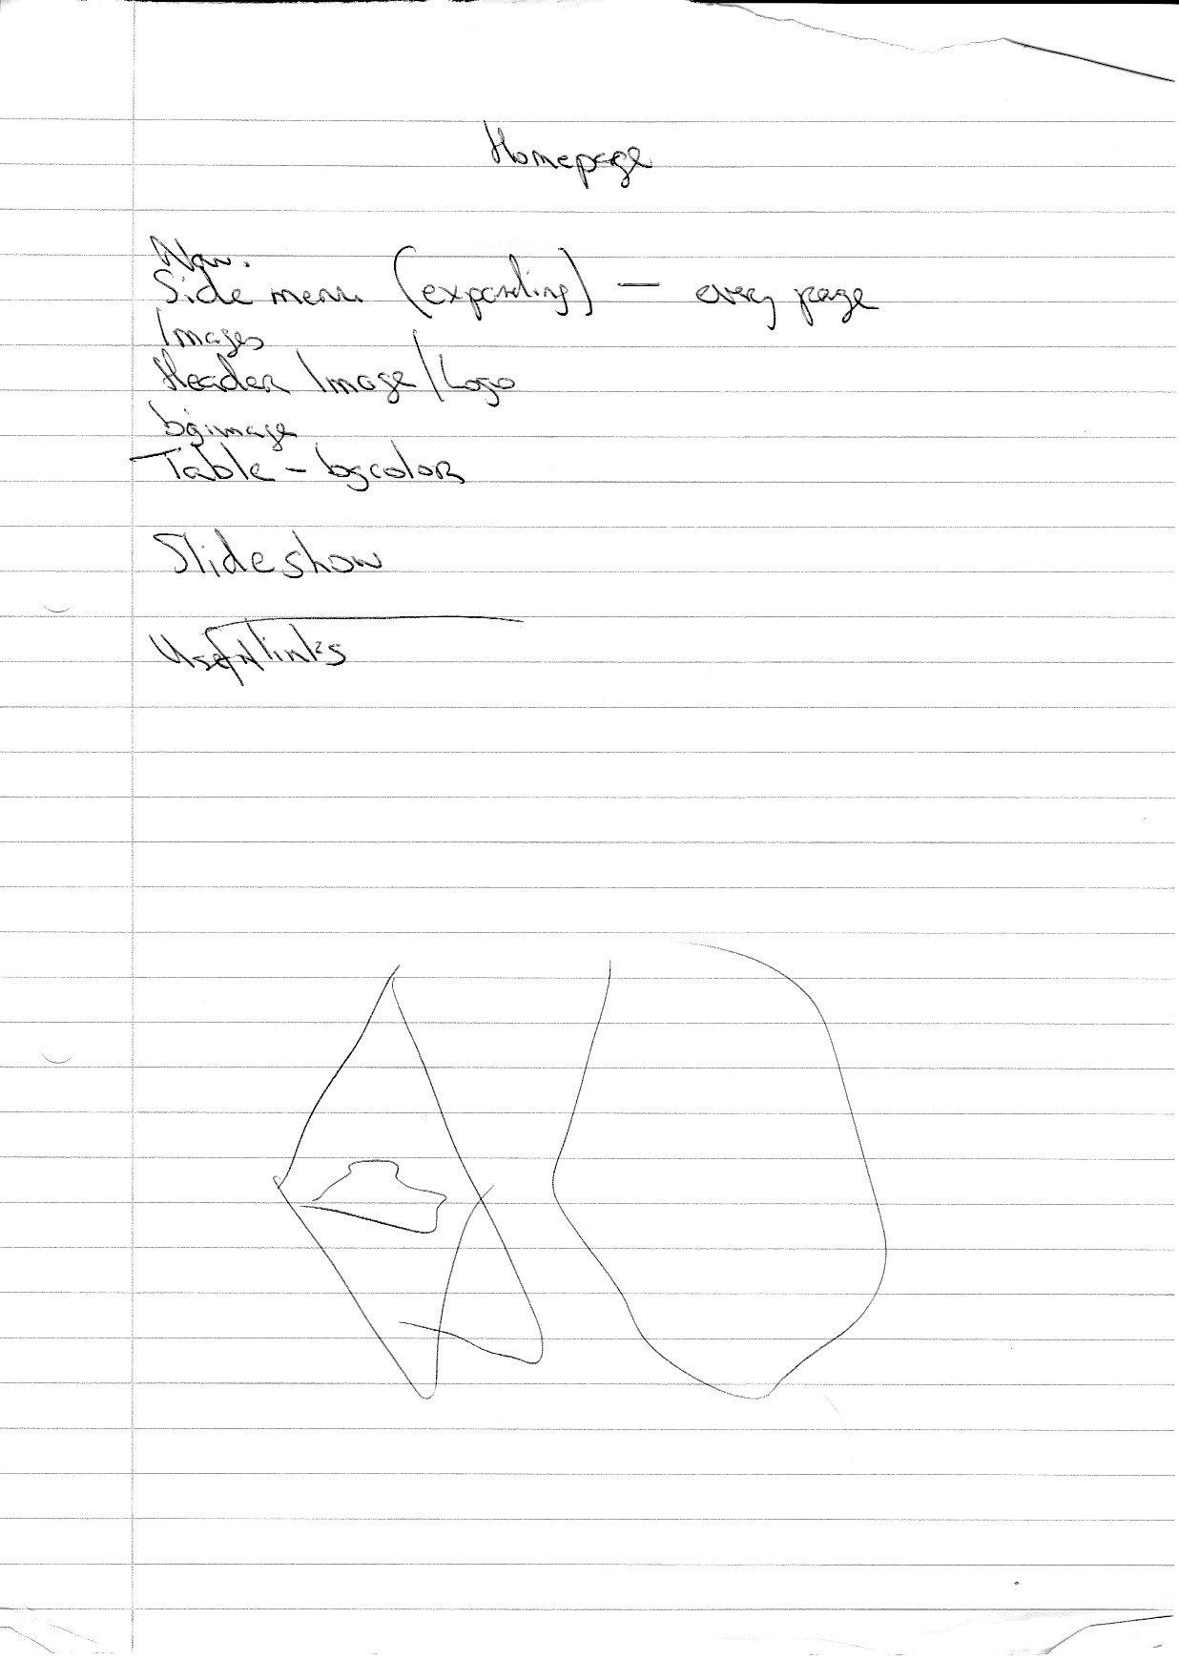**Template 4 Group Action Plan**



**Group Action Plan**

List the tasks your group needs to complete

Assign tasks to each group member and agree on appropriate timelines

**Action Plan – Date is deadline for item**

**Group assignments:**

1. Come up with ideas for our company, Nolan Motors Car Showroom **– 31/10/2015**

2. Create the requirements of the website. – **31/10/2015**

3. Look at sites with similar interest and see what makes for a good site and what makes for a bad site. (Write these down in Word or on paper) **– 31/10/2015**

4. Create mock-ups and wireframes of what the site will look like – **31/10/2015**

5. Assign each member a section of the site to do – **18/10/2015**

6. Create aesthetics of the website; colour, positioning, etc (Create CSS page). All pages should generally look the same. – **8/11/2015**

7. Create HTML code that will be used on all pages. **8/11/2015**

8. Create Presentation (10 min each) – **5/12/2015**

9. Present Project – **12/12/2015**

**Dermot’s assignments:**

About section

1. Do research on Nolan Motors Car Showroom, have they given you any information on what the company is about? (Ask Eamon, as it’s his company, he’s our client.) – **31/10/2015**

2. Look at other websites of similar interest and see what makes for a good and bad About section. Write down on Word or paper what you think looks good and what look bad on these sites. **– 31/10/2015**

3. Ask Eamon on other things he may want in the About section, he is the client after all. **– 31/10/2015**

4.

Requirements for About section: **– 31/10/2015**

* History / Mission of the company

* Our goal

* Contact information (or form) including maps and social links

* Example of our major customers.

* Information on finance that’s available.

(These could possibly go on 1 to 2 pages, but no more than 4)

5. Use the HTML code that will be used on all pages and work from that to create your section **– 29/11/2015**

Don’t forget to link pages!!!

6. Create your section using HTML code. Don’t forget to validate your pages. **– 29/11/2015**

**Cedric’s assignments:**

Showroom

1. Do research on Nolan Motors Car Showroom, have they given you any information on what content should go there? Have you consulted them? (Ask Eamon, as it’s his company, he’s our client.) **– 31/10/2015**

2. Look at other websites of similar interest and see what makes for a good and bad Showroom sections. Write down on Word or paper what you think looks good and what look bad on these sites. **– 31/10/2015**

3. Ask Eamon on other things he may want in the Showroom section, he is the client after all. **– 31/10/2015**

4. Requirements for the Showroom: **– 31/10/2015**

* About section for the showroom (introduction, max 250 words)

* Products

* Mercedes

* Audi

* Nissan

* Renault

* Etc

* Information on trade-ins

* Slideshow on main Showroom page

* Test-drive contact form

* Paypal deposit section

* Build your own car? Customisation?

* Blog

* Anything else you think might benefit the site.

(Don’t make it too complicated for yourself.)

5. Use the HTML code that will be used on all pages and work from that. **– 29/11/2015**

Don’t forget to link pages!!!

6. Create your section using HTML code. Don’t forget to validate your pages. **– 29/11/2015**

**Keith’s assignments:**

Home page and Shop section

1. Do research on Nolan Motors Car Showroom, have they given you any information on what content should go there? Have you consulted them? (Ask Eamon, as it’s his company, he’s our client.) **– 31/10/2015**

2. Look at other websites of similar interest and see what makes for a good and bad Homepage and Shop sections. Write down on Word or paper what you think looks good and what look bad on these sites. **– 31/10/2015**

3. Ask Eamon on other things he may want in the Showroom section, he is the client after all. **– 31/10/2015**

4. Requirements for Home page **– 31/10/2015**

(This section can be done by any of us)

- Links

- Sidebar menu

- Mini contact section on bottom

- Make the homepage attractive and enticing with the likes of deals and special offers

Requirements for Shop **– 31/10/2015**

- Parts can be ordered online

- Repair prices / NCT offers

- Promotions (e.g. free servicing for 1 year if you buy a car from us)

- Accessories (e.g. smart devices, satnav, alarms, air fresheners)

5. Use the HTML code that will be used on all pages and work from that. **– 29/11/2015**

Don’t forget to link pages!!!

6. Create your section using HTML code. Don’t forget to validate your pages. **– 29/11/2015**

**Template 5 Individual Action Plan**

**Group member 1 should fill in this page**

**Individual Action Plan**

Based on the task(s) assigned to you – record and synopsise your findings under the headings below.

Student Details: Student Name: **Keith Feeney** Student Number: **15015556**

1. What task(s) have you been assigned?

**I have been assigned the tasks of creating the home page and the Shop / Service Centre of the website. This involves getting the relevant information from different websites online and comparing them and assessing what makes a good and bad shop/service centre section. I will be using elements of the good parts and not using the bad parts. I have also been assigned creating the HTML for the home page and the Shop / Service Centre section as well.**

1. What information did you find out from your research?

**I’ve learnt that many websites are using bad HTML coding that could be easily fixed. Some colouring of certain sites made the text difficult to read. Some websites didn’t have enough information, had too many photos or too little photos. There should be a balance between these.**

1. Explain how this information may be useful in the development of the website.

**There needs to be a balance between text and photos. The site needs to look visually appealing with providing the relevant information. The colours of the site should not impact it too much, but compliment the site.**

1. What are you going to feedback to the group?

**I am going to feedback to the group of what the site should look like aesthetically, along with the requirements that are needed.**

1. Reference the information you have found.

**AtlasAutoService.ie** (Atlas Tyres & Autoservice, 2015)

**AORMotors.ie** (AOR Motors Ltd, 2014)

**AdvancePitStop.com** (Advance Pitstop, 2014)

**Individual Action Plan**

**Group Member 2 should fill in this page**

**Individual Action Plan**

Based on the task(s) assigned to you – record and synopsise your findings under the headings below.

Student Details: Student Name **Cedric Vecchionacce** Student Number **15011071**

1. What task(s) have you been assigned?

* **Showroom page.**
* **Research, Analysis and coding of the page.**
* **Attract customers and display all model features to increase sales.**
* **Good internal navigation menu.**
* **Wireframe, mock-ups and DOM.**

1. What information did you find out from your research?

**Some of the "car showroom pages" have the concept implied, so instead of making one page dedicated to explain features and design, they make the navigation process in a way the customer feels as if it is already in the showroom page, they also focus on life style. Some others just have a gallery with some pictures and some others focus on technical specs more than images.**

1. Explain how this information may be useful in the development of the website.

**By gathering all this information I was able to save a lot of time by looking at some good and no so good examples. I was able to detect some key and interesting information on how to improve the usability and navigation of the page, by organizing information better and giving tools to people with disabilities. I was also able to develop a basic but well organized page to work on and start testing my ideas.**

1. What are you going to feedback to the group?

**I´ve made some wireframes and sketches on paper sowing how the showroom is going to look in design and some notation with a DOM that explains how the page will work. I´ve listed some pages and examples from my research to explain some features I will love to add to the page. I've also found some examples for the about page that I want to give to my colleagues. Some of the information gathered until now has not been analysed and used yet but will be included in further reports.**

1. Reference the information you have found.

[**www.audi.com**](http://www.audi.com) **(layout, design, code)** (Audi AG, 2015)

[**www.porsche.com**](http://www.porsche.com) **(layout, design, code)** (Porsche, 2015)

[**www.ferrari.com**](http://www.ferrari.com) **(layout, design, code)** (Ferrari S.p.A., 2015)

[**www.crownmercedes.com**](http://www.crownmercedes.com) **(layout, design, code)** (Crown Dublin, 2015)

[**www.w3schools.com**](http://www.w3schools.com) **(code, references, validation)** (Refsnes Data, 2015)

[**www.porschedublin.ie**](http://www.porschedublin.ie) **(layout, design, code)** (Porsche Cars Great Britain, Ltd, 2015)

[**www.MSL.ie**](http://www.MSL.ie) **(layout, design, code)** (Motor Services Limited, 2015)

[**www.bradysmercedes-benz.ie**](http://www.bradysmercedes-benz.ie) **(layout, design, code)** (Bradys Mercedes-Benz (Dublin) Ltd , 2015)

[**www.mercedesbenz.ie**](http://www.mercedesbenz.ie) **(layout, design, code)** (Motor Distributors Ltd, 2015)

**Individual Action Plan**

**Group Member 3 should fill in this page**

**Individual Action Plan**

Based on the task(s) assigned to you – record and synopsise your findings under the headings below.

Student Details: Student Name **Dermot Forde** Student Number **15011682**

1. What task(s) have you been assigned?

I have been assigned the ABOUT page.

1. What information did you find out from your research?

The information that i found out was what goes into an About page like the history about the garage and face book and twitter links

1. Explain how this information may be useful in the development of the website.

For people coming to buys cars of the website its nice to know a little about the staff and the history of the company.

1. What are you going to feedback to the group?

what i am going to feed back to the group is that i done four pages 1. The About 2. Testimonials. 3. Used Cars and 4. Finance and yet all i can show is the ABOUT page.

1. Reference the information you have found

## Template 6 Reflection

**Group Member 1 should fill in this page**

**REFLECTION**

It is important for the group to reflect on how they arrived at the solution and the solution itself and to identify what could be improved on next time. (Students should complete about 500 words reflection)

Student Details: Student Name: **Keith Feeney** Student Number: **15015556**

1. Overall what has the experience been like working as part of a project team?

**As I worked part of a team in my QQI Level 5 course, I kind of knew what to expect working as part of a group. As a group, we decided that I would be Project Manager. We had a few meetings to help everyone understand our roles, what we all were doing and to “read from the same page” as it were. I think for me, personally I found it difficult to organise everything at the beginning and comprehend how to assign tasks to everyone. I didn’t know where to begin. It was kind of daunting. But after the first meeting, I had a better understanding and was more easily able to do the job at hand. Regarding the meetings, I had to force people to contribute into the conversation which was slightly irritating. I would have liked a lot more feedback instead of having “yes men”. Dermot seemingly was unable to do the coding for the site, but I asked our lecturer on what I should do, who advised me to inform Dermot that there are extra classes for coding available. But overall, Cedric seems to be a very nice person that is willing to put in the work that is required from him.**

1. What have been the most positive parts?

**The most positive parts have been the meetings and the vital communication between three of us. The meetings have helped us understand what is expected of each of us and also to create ideas of what we could do for the website along with sketches and wireframes for the site. I needed to hold Cedric back a small bit as I feel he was going too far ahead. He seemingly was ready to start on the HTML straight away which it difficult to do without the research and preparation behind it. I feel that’s a positive thing for the project, so that everyone could still stay on the same page and not be at different stages, which is important to keep everything organised.**

1. What could be improved on next time?

**For me, I feel that organisation is key. I don’t think I was organised enough at the beginning. Leaving things to the last minute is seriously not a good idea, as I’m finding out now as I type this. For the next time, I would ensue that I’m well organised and do tasks as I and we get them. Another thing I would consider is to have at least three project meetings a week to ensure that everyone was well informed and knew where we all are on the project. Communication is key after all. I would also consider having people doing different things, like person one could do the aesthetics, person two could do the coding and person three could do the presentation instead of everyone doing different sections of the website. That would be more beneficial and would bring out the strengths of people instead of expecting people to know everything. The current project is at a disadvantage with this.**

## Template 6 Reflection

**Group Member 2 should fill in this page**

**REFLECTION**

It is important for the group to reflect on how they arrived at the solution and the solution itself and to identify what could be improved on next time. (Students should complete about 500 words reflection)

Student Details: Student Name **Cedric Vecchionacce** Student Number **15011071**

1. Overall what has the experience been like working as part of a project team?

**Well I have to be honest by saying that I´m used to work and obtain results by my-self, but that’s just because of how things have workout in my life and I´m happy to have a team to hold me back a little and learn how to work, organize and improve our methods in different ways to achieve the best results. We were able to brainstorm a little and prepare for the research, schedule some tasks for each one before coding which I found very useful. Keith is doing a great job, I noticed him a little bit overwhelmed at the beginning with the responsibility but I´m glad he accepted because I don’t have too much time to organize and supervise others at the moment. Dermot needs a little bit of support from us we need to help him let out his ideas. It´s great to see how we can improve each other’s skills as well by adding a perspective to their vision of things.**

1. What have been the most positive parts?

**Everyone has a strong and a weak side in the group and the meetings have helped us a lot to know each other and participate in a constructive way. We were able to do some sketches and wireframes for the page and that helped us understand our individual tasks a little bit better, see where we are and spot the areas we need to improve as a team to work better. Dermot is starting to communicate in some way and that is letting us help him. Keith is getting the handle of his role and is helping us stay in schedule (in my personal case hold back a little).**

1. What could be improved on next time?

**I think we can organize better in every way, have more meetings during the week to keep track of the overall work and how to link and connect each piece. I´m sure we will improve our methods and our team work as the project grows. Personally I need to work in my time management a little (daughter, college, work, projects, assignments, etc) to be more effective in my speed and results.**

## Template 6 Reflection

**Group Member 3 should fill in this page**

**REFLECTION**

It is important for the group to reflect on how they arrived at the solution and the solution itself and to identify what could be improved on next time. (Students should complete about 500 words reflection)

Student Details: Student Name **Dermot Forde** Student Number **15011682**

1. Overall what has the experience been like working as part of a project team?

I found the experience been like working as part of a project team quite good and beneficial.

1. What have been the most positive parts?TESTING CLIPBOARD ACCESS

I enjoyed doing the research and making the pages.

1. What could be improved on next time?

For the project I did an about page, this is what I put in my about page.

**About Nolan Motors**

Founded by Freddie Nolan in 1946, Eamon Nolan Motors is steeped in motor History. Under Eamon Nolan the move to Kiliney proved to be a great success and provided the platform for Nolan Motors to become one of Ireland's leading Mercedes Dealers.

Now under the experienced, innovative and dynamic management of Eamon Nolan and Jack Jones, the dealership continues to grow from strength to strength building and retaining great relationships with existing and new Mercedes customers. Nolan Motors is open for service business and retail sales. With the finest of staff both in sales and service, why not visit and experience for yourself.

Mercedes  
Mon - Fri 9.00am - 6.00pm  
Sat 10.00am – 2.00pm.

I also did a TESTIMONIALS page and this is what I put in my TESTIMONIALS page.

**Testimonials**

"I am always happy with the service from Nolan Motors and since the recall has been done the car is going great. He mentioned that the staff behind the counter are always great and it's important that I always feels comfortable walking in there and knows that I'll get looked after every time and it never fails. I tell everyone I can how good the service is because the team deserve it for their hard work and because they genuinely care." - Keith E

**“***Excellent service and Jack was great! It is a shame that other service outlets cannot provide service this good. In fact I intend to tell everyone I run into just how good it is because it was outstanding.” - Robert O*

*"I would recommend people to come to see Nolan's just because of the amazing work done by Jasmine in service. The whole experience exceeded my expectations. Jasmine was professional, clear, precise and really friendly to deal with." -* Sam S

Nolan's Motors couldn't have done better. I looked at many different makes and models, and with Nolan's I liked the vehicle and I liked the dealership so I bought it. Overall a happy customer." - Peter STESTING CLIPBOARD ACCESS

## Template 7 Bibliography

**Referencing**

You must reference any books, articles, or web pages which you used to create your web pages. This might include content for your site or resources on how to use a piece of JavaScript code. You must use the **Harvard Referencing Style**. There are resources on moodle to help you with this style

# **References**

Advance Pitstop, 2014. *Advance Pitstop.* [Online]   
Available at: http://advancepitstop.com/  
[Accessed 29 October 2015].

AOR Motors Ltd, 2014. *AOR Motors.* [Online]   
Available at: http://www.aormotors.ie/  
[Accessed 29 October 2015].

Atlas Tyres & Autoservice, 2015. *Atlas Autoservice.* [Online]   
Available at: http://www.atlasautoservice.ie/  
[Accessed 29 October 2015].

Audi AG, 2015. *Welcome to the world of Audi.* [Online]   
Available at: http://www.audi.com  
[Accessed 27 November 2015].

Bradys Mercedes-Benz (Dublin) Ltd , 2015. *Bradys Mercedes-Benz (Dublin) Ltd.* [Online]   
Available at: http://www.bradysmercedes-benz.ie/  
[Accessed 27 November 2015].

Crown Dublin, 2015. *Crown Eurocars.* [Online]   
Available at: http://www.crownmercedes.com/  
[Accessed 27 November 2015].

Ferrari S.p.A., 2015. *Ferrari.com.* [Online]   
Available at: http://www.ferrari.com/en_en/  
[Accessed 27 November 2015].

Motor Distributors Ltd, 2015. *Mercedes-Benz. The best or nothing.* [Online]   
Available at: http://www.mercedes-benz.ie/  
[Accessed 27 November 2015].

Motor Services Limited, 2015. *MSL Motor Group.* [Online]   
Available at: http://msl.ie  
[Accessed 27 November 2015].

Porsche Cars Great Britain, Ltd, 2015. *Porsche.* [Online]   
Available at: http://www.porschedublin.ie/  
[Accessed 27 November 2015].

Porsche, 2015. *Welcome to Porsche.* [Online]   
Available at: http://porche.com  
[Accessed 27 November 2015].

Refsnes Data, 2015. *HTML: The language for building web pages.* [Online]   
Available at: http://www.w3schools.com/  
[Accessed 27 November 2015].

## Template 8 Peer Review

**PEER REVIEW**

When all group members contribute equally it makes sense for everyone to get the same result. However, if group members do not contribute evenly it is only fair that each group member receives the mark that truly reflects their contribution.

Each group member can earn a maximum of 10 marks for their contribution. Group members who made little or no contribution will receive fewer marks. The group must collectively rate each member’s contribution in the grid below by writing the member’s name in the box the group feels is most appropriate.

|  |  |  |  |
| --- | --- | --- | --- |
| **Main Contributor(s)**  **3D smiley 1**  **10 marks** | **Secondary Contributor(s)**  3D smiley 5  **7 marks** | **Minimal Contribution**  3D smiley 3  **3 marks** | **No Contribution**  [Picture]  **0 marks in Assignment** |
|  |  |  |  |

I **___________** agree with the marks that have been awarded for my contribution to the assignment.

I ___________ agree with the marks that have been awarded for my contribution to the assignment.

I **___________** agree with the marks that have been awarded for my contribution to the assignment.